Experiment 5.1
StudentName: Ayush Branch: CSE  Semester: 6th  Subject: PBLJ | UID: 22BCS15510 Section:608/A  DOP:25/02/25  Subject Code:22CSH-359
Aim: Write a Java program to calculate the sum of a list of integers using autoboxing and unboxing. Include methods to parse strings into their respective wrapper classes (e.g., Integer.parseInt()).
Objective: Demonstrate autoboxing and unboxing in Java by converting string numbers into Integer objects, storing them in a list, and computing their sum.
Algorithm:

Step 1: Initialize the Program
- Start the program.
- Import ArrayList and List classes.
- Define the AutoboxingExample class.

Step 2: Convert String Array to Integer List
- Define the method parseStringArrayToIntegers(String[] strings).
- Create an empty ArrayList<Integer>.
- Iterate through the string array:
  - Convert each string to an Integer using Integer.parseInt(str).
  - Add the integer to the list (autoboxing happens here).
- Return the list of integers.

Step 3: Calculate the Sum of Integers
- Define the method calculateSum(List<Integer> numbers).
- Initialize a variable sum to 0.
- Iterate through the list:
  - Extract each integer (unboxing happens here).
  - Add it to sum.
- Return the total sum.

Step 4: Execute Main Function
- Define main(String[] args).
- Create a string array with numeric values.
- Call parseStringArrayToIntegers() to convert it into a list of integers.
- Call calculateSum() to compute the sum.
- Print the result.

Step 5: Terminate the Program
1. End the execution.
Code:
import java.util.ArrayList;
import java.util.List;

public class AutoboxingExample { public static void main(String[] args) {
String[] numberStrings = {"10", "20", "30", "40", "50"};

List<Integer> numbers = parseStringArrayToIntegers(numberStrings);

int sum = calculateSum(numbers);

System.out.println("The sum of the numbers is: " + sum);
}

public static List<Integer> parseStringArrayToIntegers(String[] strings) {
List<Integer> integerList = new ArrayList<>();
for (String str : strings) {
integerList.add(Integer.parseInt(str));
}
return integerList;
}

public static int calculateSum(List<Integer> numbers) { int sum = 0;
for (Integer num : numbers) { sum += num;
}
return sum;
}
}
Output:
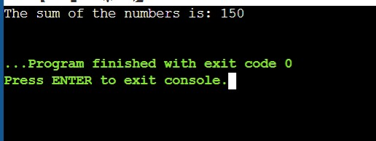
Learning Outcomes:
- Understand the concept of autoboxing and unboxing in Java and how primitive types are automatically converted to their wrapper classes and vice versa.
- Learn how to convert string values into Integer objects using Integer.parseInt() and store them in a list.
- Gain experience in working with ArrayLists to store and manipulate a collection of numbers dynamically.
- Develop proficiency in iterating through collections and performing arithmetic operations like summation.

Experiment 5.2

1.Aim: Create a Java program to serialize and deserialize a Student object. The program should:
- Serialize a Student object (containing id, name, and GPA) and save it to a file.
- Deserialize the object from the file and display the student details.
- Handle FileNotFoundException, IOException, and ClassNotFoundException using exception handling.

2.Objective: The objective is to serialize and deserialize a Student object, store and retrieve its id, name, and GPA from a file, and handle exceptions like FileNotFoundException, IOException, and ClassNotFoundException.

3.Algorithm:
Step 1: Initialize the Program
  - Start the program.
  - Import the necessary classes (java.io.*).
  - Define a Student class implementing Serializable.
  - Declare attributes:
    - id (int) o name (String) o gpa (double)
  - Define a constructor to initialize Student objects.
  - Override toString() to display student details.
Step 2: Define the Serialization Method
  - Create serializeStudent(Student student).
  - Use a try-with-resources block to create an ObjectOutputStream:
    - Open a FileOutputStream to write to student.ser.
    - Write the Student object to the file using writeObject().
  - Handle exceptions:
    - FileNotFoundException → Print error message.
    - IOException → Print error message.
  - Print a success message if serialization is successful.
Step 3: Define the Deserialization Method
  - Create deserializeStudent().
  - Use a try-with-resources block to create an ObjectInputStream:
    - Open a FileInputStream to read student.ser.
    - Read the Student object using readObject().
3. Handle exceptions:
    - FileNotFoundException → Print error message.
    - IOException → Print error message.
    - ClassNotFoundException → Print error message.
4. Print the deserialized student details.
Step 4: Execute Main Function
  - Define main(String[] args).
  - Create a Student object with sample data.
  - Call serializeStudent() to save the object.
  - Call deserializeStudent() to read and display the object.
Step 5: Terminate the Program
1. End execution.
4. Implementation Code:
import java.io.*;

class Student implements Serializable { private static final long serialVersionUID = 1L; private int id; private String name; private double gpa;

public Student(int id, String name, double gpa) { this.id = id; this.name = name; this.gpa = gpa;
}

@Override
public String toString() {
return "Student{id=" + id + ", name='" + name + "', gpa=" + gpa + "}";
}
}

public class StudentSerialization {
private static final String FILE_NAME = "student.ser";

public static void main(String[] args) {
Student student = new Student(1, "Anwar", 7.8);
serializeStudent(student);
deserializeStudent();
}

public static void serializeStudent(Student student) {
try (ObjectOutputStream oos = new ObjectOutputStream(new
FileOutputStream(FILE_NAME))) {
oos.writeObject(student);
System.out.println("Student object serialized successfully.");
} catch (FileNotFoundException e) {
System.err.println("File not found: " + e.getMessage());
} catch (IOException e) {
System.err.println("IOException occurred: " + e.getMessage());
}
}

public static void deserializeStudent() {
try (ObjectInputStream ois = new ObjectInputStream(new FileInputStream(FILE_NAME))) {
Student student = (Student) ois.readObject();
System.out.println("Deserialized Student: " + student);
} catch (FileNotFoundException e) {
System.err.println("File not found: " + e.getMessage());
} catch (IOException e) {
System.err.println("IOException occurred: " + e.getMessage());
} catch (ClassNotFoundException e) {
System.err.println("Class not found: " + e.getMessage());
}
}
}
5.Output
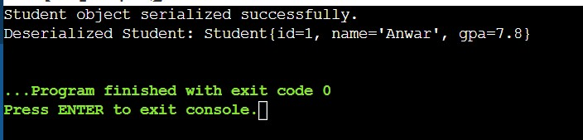

6.Learning Outcomes:
- Understand object serialization and deserialization in Java.
- Learn how to use ObjectOutputStream and ObjectInputStream for file operations.
- Implement exception handling for FileNotFoundException, IOException, and ClassNotFoundException.
- Gain hands-on experience in storing and retrieving objects from a file.
- Develop skills in data persistence and file management using Java.

Experiment 5.3
- Aim: Create a menu-based Java application with the following options.
1.Add an Employee
- Display All
- Exit If option 1 is selected, the application should gather details of the employee like employee name, employee id, designation and salary and store it in a file. If option 2 is selected, the application should display all the employee details. If option 3 is selected the application should exit.
- Objective: The objective is to develop a menu-based Java application that allows users to add employee details, store them in a file, and display all stored employee records, with an option to exit the program.

- Algorithm:

Step 1: Initialize the Program
- Start the program.
- Import java.util.* and java.util.concurrent.* for thread handling.
- Define a class TicketBookingSystem with:
  - A List<Boolean> representing seat availability (true for available, false for booked).
  - A synchronized method bookSeat(int seatNumber, String passengerName) to ensure thread safety.

Step 2: Implement Seat Booking Logic
1. Define bookSeat(int seatNumber, String passengerName):
- If the seat is available (true), mark it as booked (false). o Print confirmation: "Seat X booked successfully by Y".
- If already booked, print: "Seat X is already booked."

Step 3: Define Booking Threads
1. Create a class PassengerThread extending Thread:
- Store passenger name, seat number, and booking system reference.
- Implement run() method to call bookSeat().

Step 4: Assign Thread Priorities
- Create VIP and Regular passenger threads.
- Set higher priority for VIP passengers using setPriority(Thread.MAX_PRIORITY).
- Set default priority for regular passengers.

Step 5: Handle User Input & Simulate Booking
- In main(), create an instance of TicketBookingSystem.
- Accept number of seats and bookings from the user.
- Create multiple PassengerThread instances for VIP and regular passengers.
- Start all threads using start().

Step 6: Synchronization & Preventing Double Booking
- Use the synchronized keyword in bookSeat() to ensure only one thread accesses it at a time.
- Ensure thread execution order by assigning higher priority to VIP threads.

Step 7: Display Final Booking Status
- After all threads finish execution, display the list of booked seats.
- End the program with a message: "All bookings completed successfully."

4.Implementation Code:
i import java.io.*; import java.util.*;

class Employee implements Serializable {
private static final long serialVersionUID = 1L;
private int id; private String name; private String designation;
private double salary;

public Employee(int id, String name, String designation, double salary) { this.id = id;
this.name = name; this.designation = designation; this.salary = salary;
}

@Override
public String toString() {
return "Employee ID: " + id + ", Name: " + name + ", Designation: " + designation + ", Salary: " + salary;
}
}

public class EmployeeManagementSystem { private static final String FILE_NAME = "employees.ser"; private static List<Employee> employees = new ArrayList<>();

public static void addEmployee() {
Scanner scanner = new Scanner(System.in); System.out.print("Enter Employee ID: "); int id = scanner.nextInt(); scanner.nextLine();
System.out.print("Enter Employee Name: ");
String name = scanner.nextLine();
System.out.print("Enter Designation: ");
String designation = scanner.nextLine(); System.out.print("Enter Salary: ");
double salary = scanner.nextDouble();

Employee employee = new Employee(id, name, designation, salary);
employees.add(employee);
saveEmployees();
System.out.println("Employee added successfully!");
}

public static void displayAllEmployees() {
loadEmployees(); if (employees.isEmpty()) {
System.out.println("No employees found.");
} else {
for (Employee employee : employees) {
System.out.println(employee);
}
}
}
private static void saveEmployees() {
try (ObjectOutputStream oos = new ObjectOutputStream(new
FileOutputStream(FILE_NAME))) {
oos.writeObject(employees);
} catch (IOException e) {
System.err.println("Error saving employees: " + e.getMessage());
}
}

@SuppressWarnings("unchecked") private static void loadEmployees() {
try (ObjectInputStream ois = new ObjectInputStream(new
FileInputStream(FILE_NAME))) {
employees = (List<Employee>) ois.readObject();
} catch (FileNotFoundException e) { employees = new ArrayList<>();
} catch (IOException | ClassNotFoundException e) {
System.err.println("Error loading employees: " + e.getMessage());
}
}

public static void main(String[] args) {
Scanner scanner = new Scanner(System.in);
while (true) {
System.out.println("\nEmployee Management System");
System.out.println("1. Add an Employee");
System.out.println("2. Display All Employees");
System.out.println("3. Exit"); System.out.print("Enter your choice: ");
int choice = scanner.nextInt();
scanner.nextLine();

switch (choice) { case 1: addEmployee(); break; case 2:
displayAllEmployees(); break; case 3:
System.out.println("Exiting...");
return; default:
System.out.println("Invalid choice! Please try again.");
}
}
}
}

- Output:
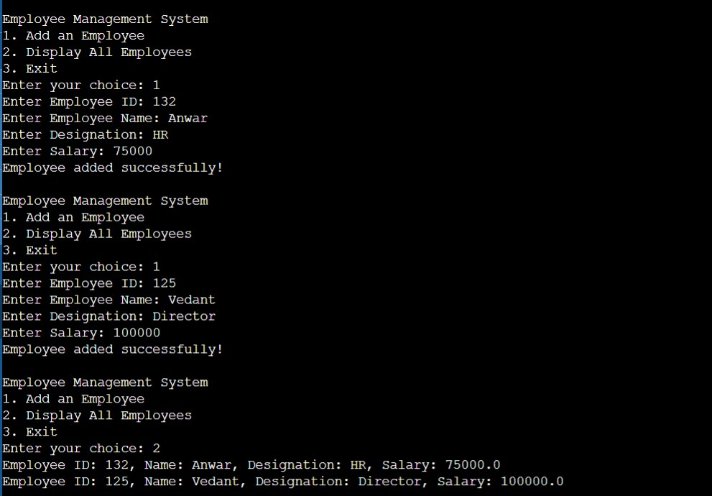

- Learning Outcomes:
- Understand file handling and serialization in Java to store and retrieve objects persistently.
- Learn how to implement a menu-driven console application using loops and conditional statements.
- Gain experience in object-oriented programming (OOP) by defining and managing Employee objects.
- Practice exception handling to manage file-related errors like FileNotFoundException and IOException.
- Develop skills in list manipulation and user input handling using ArrayList and Scanner.

